Step to Clone a Repository from Github via GIT Gui

* Click on Clone a repository

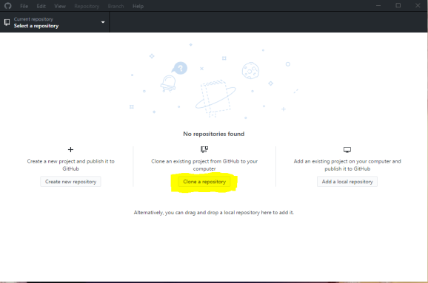

* Paste the below url of the git repository and give the path of your system where you want create the repository locally:

<https://github.com/abhinav5397/Way2Automate.git>

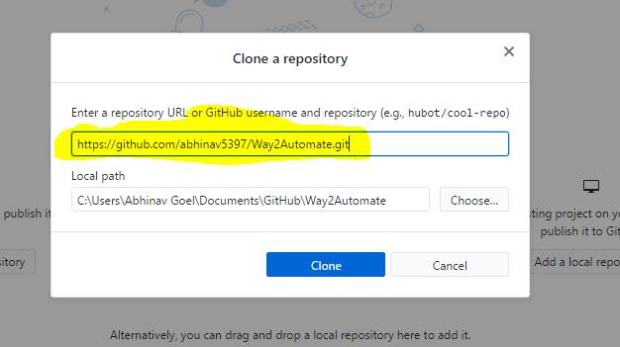

* Click on the clone button
* Once cloned the the GIT gui will appear as :

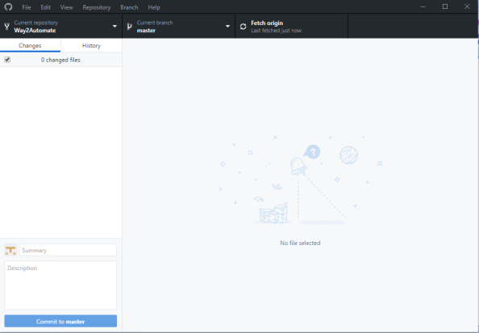

* Open the File location where the local repository is created

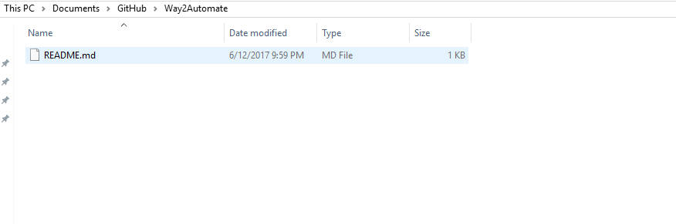

* The Repository is cloned successfully